Critical Review Form
Meta-Analysis
Norman G, Christie J, Liu Z, et al. Antiseptics for burns. Cochrane Database Syst Rev. 2017;7(7):CD011821.

PGY-4

Objective: “To assess the effects and safety of antiseptics for the treatment of burns in any setting.” (p 4)
Methods:
Inclusion Criteria
These Cochrane systematic review authors included “published and unpublished randomized controlled trials (RCTs), including cluster-RCTs, irrespective of language of report.” They planned to include studies enrolling patients of any age with burn wounds of any type, severity, extent, or current infection status, managed in any care setting. “Interventions” could include topical antiseptic agents, whereas controls could include placebo, an alternative antiseptic, another therapy such as antibiotics or isolation of the patient, standard care, or no treatment. Excluded studies lacked the presence or absence of a specific antiseptic agent or antiseptics used in preparation for surgical treatment. (p 18) The authors searched the Cochrane Wounds register, CENTRAL, MEDCLINE, Embase, and CINAHL. In addition, they searched the following trial registries: ClinicalTrials.gov, World Health Organization International Clinical Trials Registry Platform, and the European Union Trials Register. Study quality was evaluated using the Cochrane Risk of Bias tool.
Outcomes
Wound healing was the primary effectiveness outcome, including (a) time to wound healing ideally adjusted for baseline wound area and degree of burn injury and (b) proportion of wounds completely healed during follow-up (using original study’s definitions for “wound healing”). The primary safety outcome was wound infection – either incidence of infection in wounds not infected at initial treatment or resolution of infection in wounds that were infected at initial treatment. Secondary outcomes sought included adverse events (pain, including at dressing change), health-related quality of life, resource use (dressing changes, number of nurse visits, hospital length of stay), costs associated with resource use, and mortality (overall and infection-related). The authors also planned a priori subgroup analyses by age (children age <18 or adults age >65), as well as by burn size and depth, as well as sensitivity analysis by removal of studies at high risk of bias. Unfortunately, insufficient studies were identified to permit any of these subgroup analyses.
Comparators
Including studies compared (a) antiseptics vs. topical antibiotics, (b) two antiseptics, or (c) antiseptics and treatments without antimicrobial properties. (pp 24-25 and see Figure).
The authors considered clinical and methodological heterogeneity (between study differences in participants, interventions, outcomes, and length of follow-up) supplemented with assessment of statistical heterogeneity including Chi-squared (p < 0.10 considered high risk) and I² (<25% considered low risk). If no clinical or statistical heterogeneity identified, the authors used a fixed-effects meta-analysis. Otherwise, a random-effects meta-analysis was planned. Publication bias was not evaluated if less than 10 RCTs existed for any intervention.
Antiseptics are defined as “topical antimicrobial agents which are thought to prevent the growth of pathogenic micro-organisms without damaging living tissue”. (p 17) Antiseptic subtypes for wound irrigation include povidone-iodine, chlorhexidine, and peroxide agents with gentian violet and hypochlorites. More commonly used products include silver sulfadiazine and silver-impregnated dressings. Honey-based products are also used. Antiseptics are the focus of this Cochrane review and are bactericidal or bacteriostatic. Antibiotics are substances that “destroy or inhibit the growth of bacterial (normally by inhibiting DNA, protein synthesis, or by disrupting the bacterial cell wall).” (p 20) Another Cochrane review (Barajas-Nava 2013) evaluate antibiotic prophylaxis for burn wounds. Routine prophylaxis against infection with systemic antibiotics is not recommended.
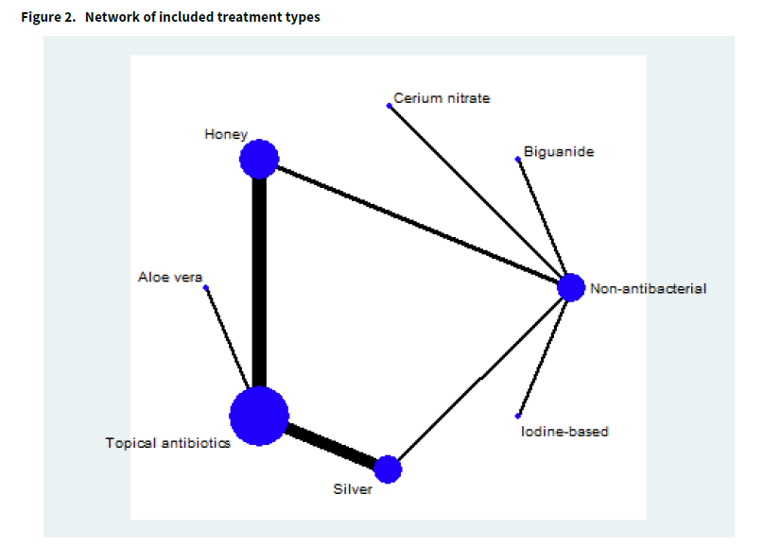

Critical Review Form: Meta-Analysis
Guide | Comments
Are the results valid?
Did the review explicitly address a sensible question? | Yes – are available and commonly used topical agents/dressings effective and safe for burn wounds in comparison with standard care, other topical agents (antiseptic or antibacterial), or placebo.
Was the search for relevant studies detailed and exhaustive? | Yes, the authors searched the Cochrane Wounds register, CENTRAL, MEDLINE, Embase, and CINAHL. In addition, they searched the following trial registries: ClinicalTrials.gov, World Health Organization International Clinical Trials Registry Platform, and the European Union Trials Register.
Were the primary studies of high methodological quality? | No studies had a low risk of bias for all domains. Only one study (Tang 2015) was low risk of bias across all except one domain. All other studies had unclear or high risk of bias. For attrition bias and reporting bias the majority of studies were at low risk of bias, but for selection bias and detection bias the majority of studies were not at low risk of bias.
Were the assessments of the included studies reproducible? | Probably. The authors use the Cochrane Risk of Bias tool, but do not report quantitative reproducibility between raters (kappa). The Cochrane authors also fail to identify the individuals conducting the GRADE assessments, nor their level of training in using GRADE. (p 21)
What are the results?
What are the overall results of the study? |  | - The authors included 56 studies reported in 66 publications totaling 5807 randomized participants in their qualitative synthesis. They included 44 studies in the quantitative synthesis (meta-analysis). (p. 24)  - Silver-based dressings (silver foam, silver hydrogel, silver alginate, nanocrystaline silver, silver hydrofiber) are not more effective than silver sulfadiazine for time to complete healing (3 RCTs, low certainty, HR 1.25; 95% CI 0.94-1.67), but heal wounds on average 3.3 days faster (10 RCTs, low certainty). No difference in adverse effects and effect on infections is uncertain.  - Honey (variously described as pure, undiluted or unprocessed) is more effective than topical antibiotics (silver sulfadiazine in 8/9 studies) to promote wound healing (5 RCTs, HR 2.45; 95% CI 1.71-3.52, moderate certainty) and heals wounds on average 3.8 days faster (6 RCTs, very low certainty). The effects on treating or preventing infections are uncertain.  - Aloe vera has inadequate evidence to understand effect on wound healing, infection rates, or adverse events when compared with topical antibiotics (very low certainty).  - Iodine has inadequate evidence to understand effect on wound healing, infection, or adverse events when compared with topical antibiotics (very low certainty).  - Silver-based dressings heal on average 3.5 days faster than silver xenograft or petroleum gauze dressings (2 RCTs, moderate certainty).  - Honey-based dressings (honey soaked gauze) are more likely than non-antibacterial dressings/topical treatments (bio-occlusive, moisture-permeable polyurethane dressing) to promote complete wound healing (2 RCTs, HR 2.86; 95% CI 1.6-5.1, moderate certainty) and on average wounds heal 5.3 days faster (4 RCTs, high certainty). The effects on infection prevention or treatment are uncertain.  - Chlorhexidine increases the time to wound healing by on average 4 days compared with non-antibacterial dressings (1 RCT, low certainty). The effects on infection are uncertain.  - Iodine-based treatments increases average time to wound healing by 5.4 days compared with carbon fiber (1 RCT, very low certainty), but decreases wound healing by 26 days compared with moist exposed burn ointment.
How precise are the results? |  | Sufficiently precise for some treatments for some outcomes. See 95% CI above
Were the results similar from study to study? |  | Not consistently because the original studies tested different treatments and assessed outcomes using self-defined measures. Therefore, in some instances meta-analysis was not possible.
Will the results help me in caring for my patients?
How can I best interpret the results to apply them to the care of my patients? |  | Evidence of benefit for atypical (and generally unavailable) topical treatments like honey exist with moderate certainty. More commonly used burn topical therapies like silver sulfadiazine do not appear superior to silver-impregnated dressings, iodine, or non-adhesive petroleum gauze except perhaps in time to wound healing.
Were all patient important outcomes considered? |  | Unfortunately, although the authors planned to evaluate pain and health-related quality of life, there studies did not address these patient-centric outcomes. Cost comparisons between these different topical agents would also add value for patients and society.
Are the benefits worth the costs and potential risks? |  | Uncertain based upon the available studies.

Limitations:
- Heterogeneous interventions evaluated, some using topical agents not typically used or readily available in today’s ED.
- Inadequate studies to evaluate pre-planned subgroup analyses (age, burn severity), costs, or patient-centric outcomes (pain, wound appearance).
- Overall, low quality evidence with most findings very low or low certainty by GRADE criteria.
Bottom Line:
In terms of wound healing, the most effective topical agent appears to be one EDs do not use: honey. More commonly applied topical agents like silver sulfadiazine do not appear superior to honey or other silver-impregnated dressings to promote wound healing. Silver sulfadiazine may be superior to petroleum gel in terms of time to wound healing.

